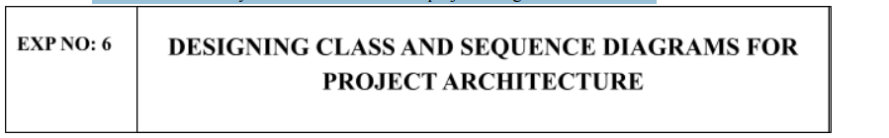
Aim:
To Design a Class Diagram and Sequence Diagram for the given Project.
6A. Class Diagram
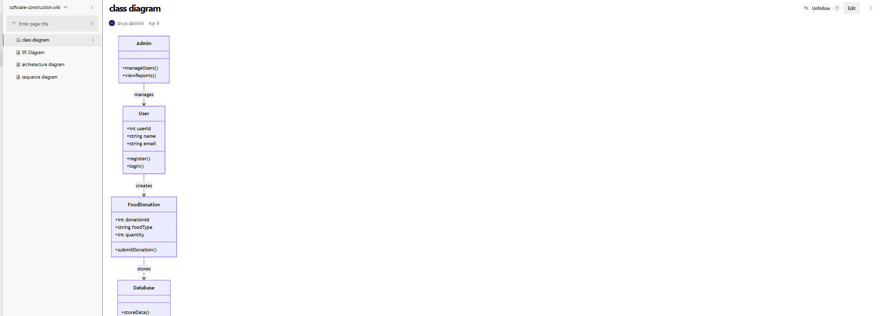
6B. Sequence Diagram
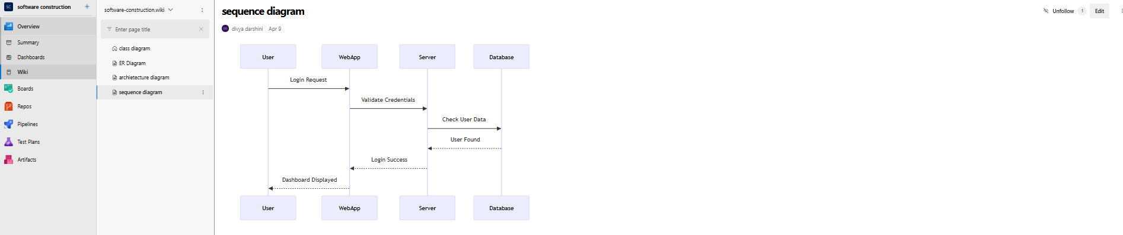

Result:
The Class Diagram and Sequence Diagram is designed Successfully for the Music Playlist Batch Creator.

